Journal Reflection 2
Social Media and Online Protection
Name: | Block:

Journal Instructions:
Read the following article and answer the following question(s) fully. Remember to write all your answers in complete sentences.

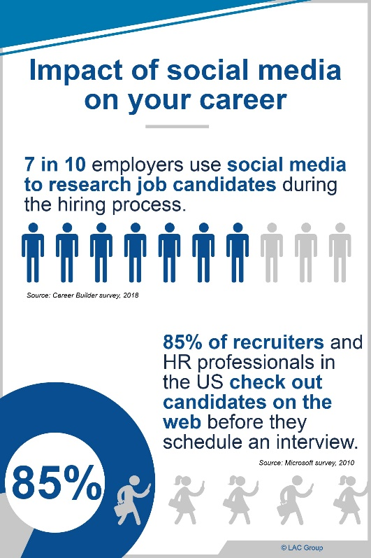
The Impact of Social Media on Employment: The Good, the Bad, and the Ugly
Author: Cornell University (New York)
Date: May 16, 2018
Vocab word: Social Media (社交网络媒介)
(Examples: QQ, WeChat, Facebook, Twitter, Instagram)
The photo you posted on Instagram, the one of you eating a fresh seafood salad with on the beach, well, you probably thought that no one out of your friends would really pay attention to it. However, you’re very wrong.
Social media has exploded over the past decade, however, it hasn’t played much of a role within society until recent years. As we continue to technologically advance, social media is taking on a huge role and affecting almost every industry imaginable. Though you may think that you’re fine and social media won’t affect your life, well, it already has. Aside from the fact that most of us are obsessed with our Facebook, WeChat, QQ, Instagram, Pinterest and Twitter accounts, social media is much more influential than validating the photo you just posted. Now, social media is changing the way people do business and changing the employer/employee relationship.
With the creation of social media, employers and employees are open to an endless source of information of one another, from job portals to online resume templates. Your current or new employer may send you a friend request on WeChat or follow you on Instagram or QQ. But this isn’t because they want to become your friend, this is a way for them to find out who you are as a person. Of course, you supplied them your resume (简历) and cover letter, however, now with social media, it’s clear that a resume (简历) is not enough. Typically, resumes identify our strongest abilities and most honorable achievements, however, they don’t provide any evidence of those abilities nor do they tell the employer of who you are. Why would they call you in for an interview when they can just Google you instead? Though they may sound appropriate on some level, the use of social media for employment can be dangerous.
In a survey done in 2016 by CareerBuilder, it found that 60% of employers used social media to determine where the candidate meets the job requirements. These social media tools give employers the ability to not only see if you meet the job requirements, but it gives them to see who you really are outside of your resume. For the employer, social media saves them training, time, and money as they’ll be able to find out your abilities prior to hiring you. You may be wondering though, “what really is the impact of social media on the hiring process, they can’t be doing that for every candidate.” Well, the CareerBuilder surveyed over 2,000 hiring managers and human resource professionals, finding out the 51% of employers who do take the time to search up candidates on social media have not hired candidates based on the content in their social media pages. Why wouldn’t they hire specific candidates? Well, some of the reasons were as followed:
- the candidate posting inappropriate or provocative pictures or content (46%)
- evidence of drinking or drug use (41%)
- discriminatory posts (28%)
- inappropriate screen names (21%)
Most of us have questionable content on our social media, depending on which angle we look at it. Your political views and the activities you take up in your spare time are all viewed under a microscope. Thus, the entire purpose of social media, which is aside from business, is to open communication between individuals, sharing views and discussing opinions is altered due to fear of being judged. Now, you may not care about what other people think of you and nor should you, however, it changes when the judgements are being made by a potential employer.
Though social media has its ugly side, there are ways where social media can be used to your advantage when applying for a job. The same study from CareerBuilder also found that 33% of employers found information which made them consider a candidate. Some of the reasons why an employer would hire a candidate after looking through their social media included:
- the candidate’s profile conveying a professional image (43%)
- the candidate’s profile portraying an individual that would be a match for the company’s culture (46%)
- the candidate appearing to be well rounded (40%)
But does the good outweigh the bad? It all depends on how you use social media. The way you manage your social media says everything about you. You need to think about the message you’re sending out about yourself through social media. What do your social media account say about you? And, if you were an employer, would you hire yourself based on your social media? In order to protect your privacy, yet, give employers just enough information on yourself, you need to do a social media cleanse. Go through all your social media pages, go through your content and remove any inappropriate material. In addition, fine-tune your security settings so that you still have control over what you want employers to see about you.
Remember, social media, though has its perks, it needs to be controlled by its users. Know the person you’re showing to the world online and to future employers.

Journal Instructions:
Answer the following questions fully (~ 6-10 lines of text). Remember to write all your answers in complete sentences and format all answers properly.
Formatting:
The questions should be answered using the following formatting options:
- Font: Times New Roman
- Font Size: 12
Do you use any social media websites or APPs, if so, which ones? Has reading this article changed how you may use your social media accounts in the future? Explain.

Using bullets to format your answer, what are four reasons the article explains as reasons why employers or universities would not accept a person based on their social media account?

Explain in detail some ways that you can protect your privacy on your social media accounts? (So that others cannot view you without your permission.)

Grading Rubric
 | 4 | 3 | 2 | 1
Content | Contains clear well-thought-out answers.  Answers are sufficiently long to show student has given the questions thought. | Answers are clear however they should be longer to show full meaning and thoughts. | Answers are more than a couple of sentences, however very little thought or understanding went into the response. | Answers are very short and contain little to no meaningful thought.
Formatting | Elements of formatting such as bold, italics, and font have been used to make the document look professional | Elements of formatting such as bold, italics, and font have mostly been used to make the document look professional | Elements of formatting been used but is not consistent. | Elements of formatting been used but makes the document difficult to read.
 | 1 | 0.75 | 0.5 | 0.25
Spacing | Spacing is used between paragraphs to make the journal very easy to read | Spacing is mostly used to make the journal easy to read | Spacing sometimes is used to help reading | Spacing is random or mostly not helpful when reading the journal
Grammar and Spelling | Few errors, reader can always understand the ideas. | Some errors, the reader can understand ideas most of the time. | Many errors, at times it is difficult for the reader to understand ideas. | Many errors, very difficult for the reader to understand ideas.
TOTAL: ____ / 10

